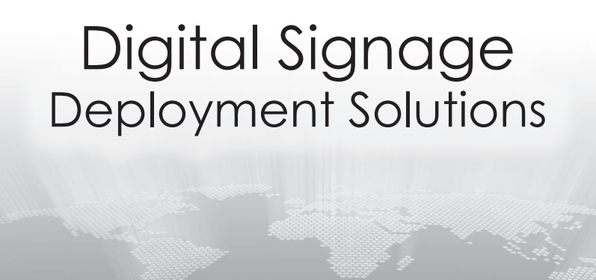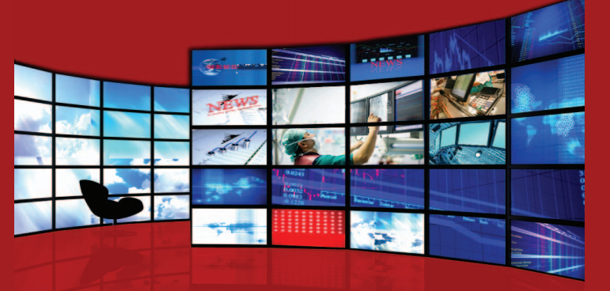

**Thank you for your interest**

**in digital signage**

In this brochure you can read all about do-it-yourself digital

digital signag, controlling the screens used within your

organisation. meramedia is a digital signage solution that allows you

to create and manage your program schedules with ease.

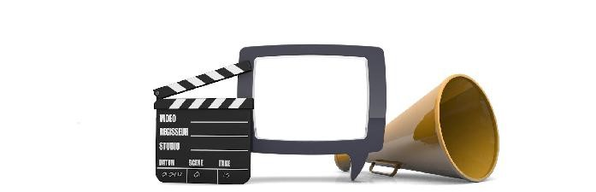

Digital media make everyone a director.

meramedia grants complete and remote fine-tune your programs depending on Using these, you can enrich your ESC

control over your digital signage. You your organisation, location and potential quickly and easily!

You can create and edit clips online and customers by using a wide variety of

broadcast them anytime. Also, you can of unique apps, widgets and other extras.

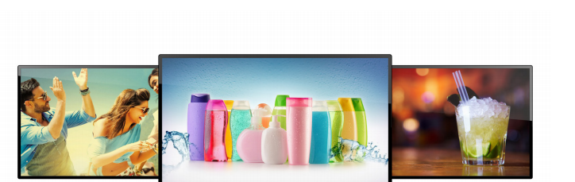

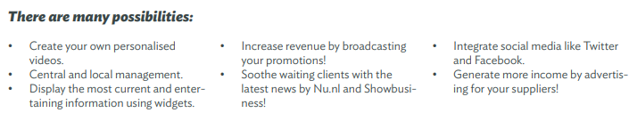

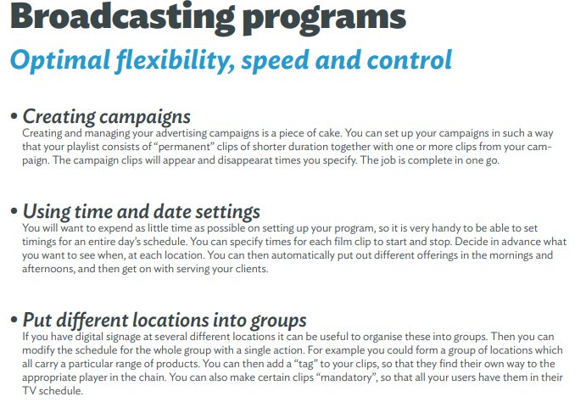

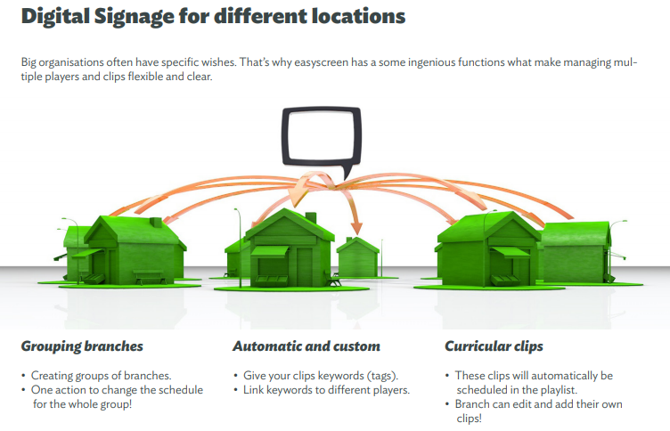

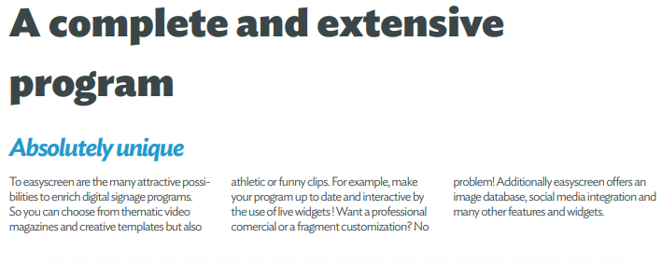

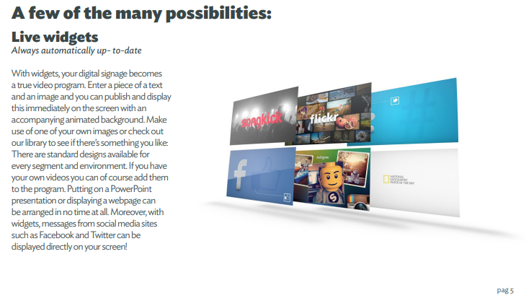

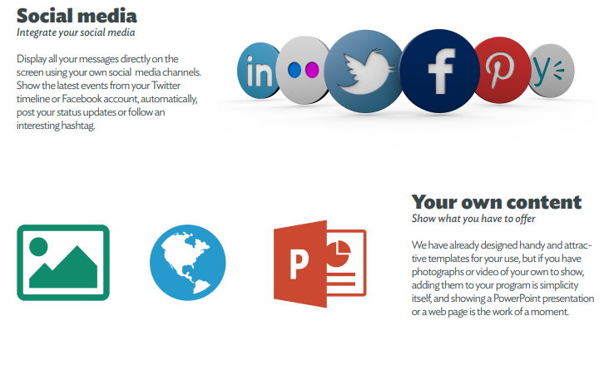

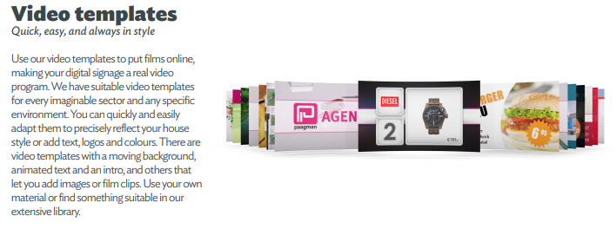

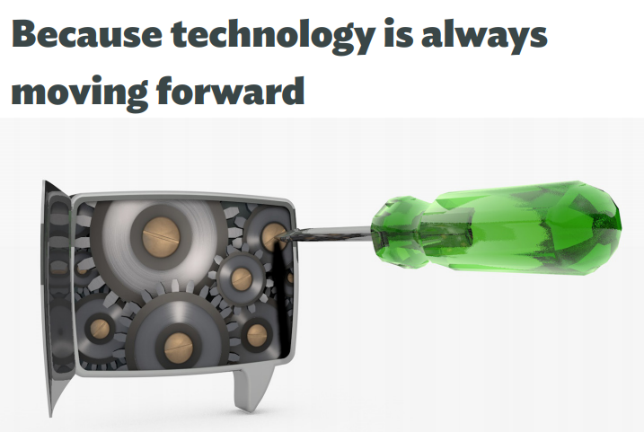

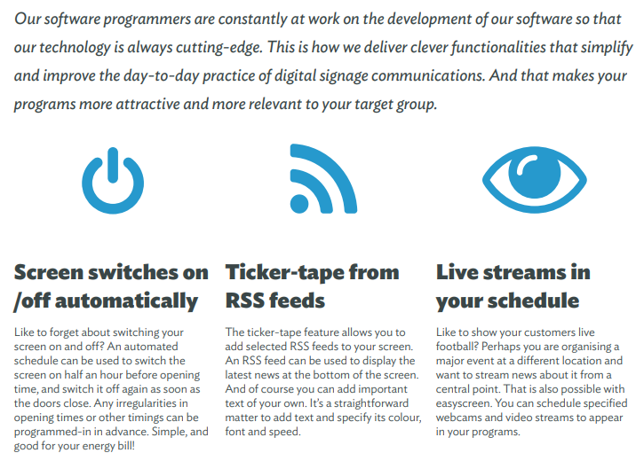

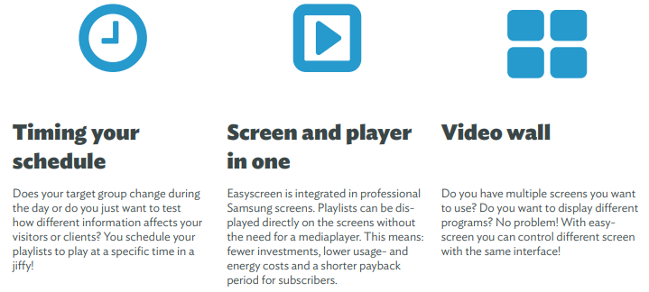

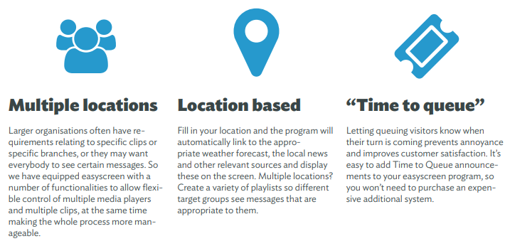

**Explore all the other**

**Possibilities**

Media is fast ,easy and mainly very flexible! In

this brochure we’ve shown the basic features,

but a lot more is possible! We’re always available

for more information

**Cinema Display Solutions**

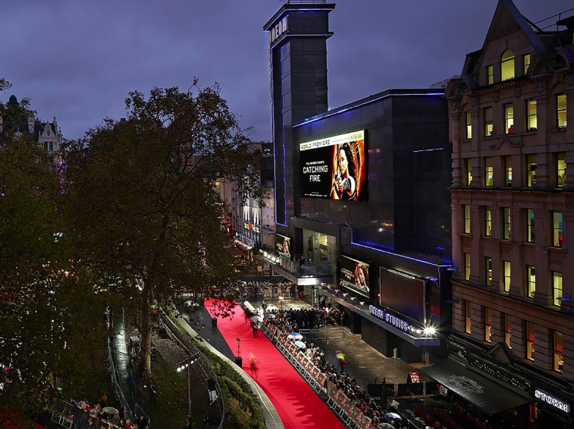

**DOOH**

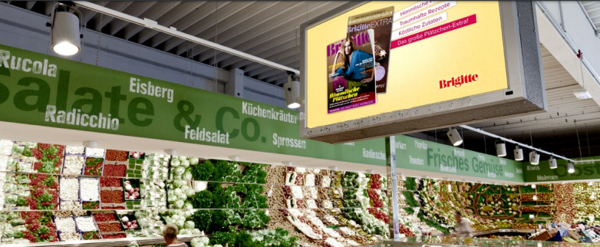

**Education**

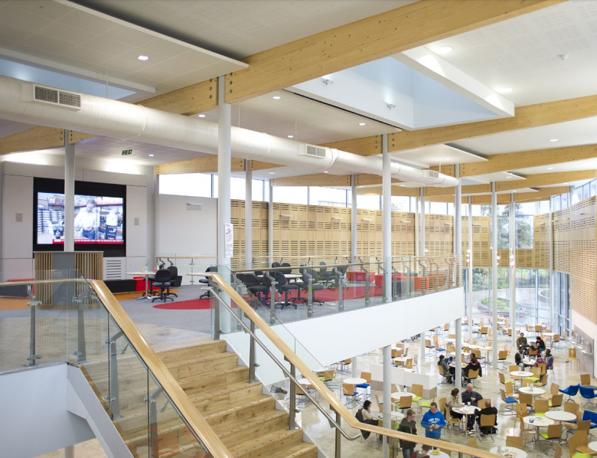

**Retail**

